Assignment 1

# Part-2 Server Setup

1. Starting the XAMP Server:

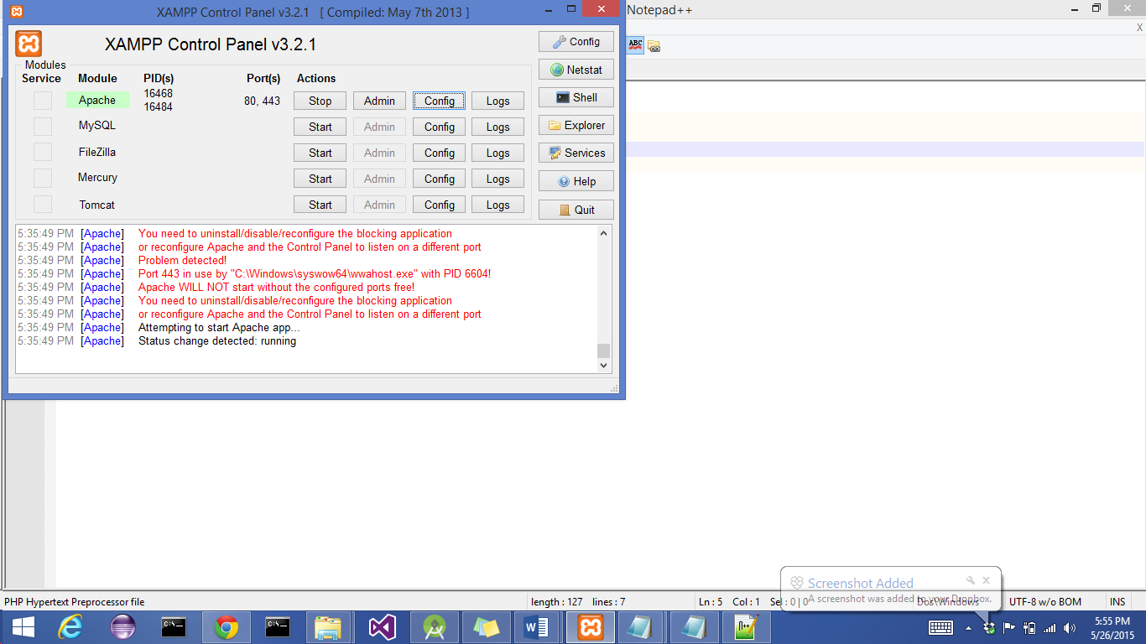

1. Modifying hosts file:

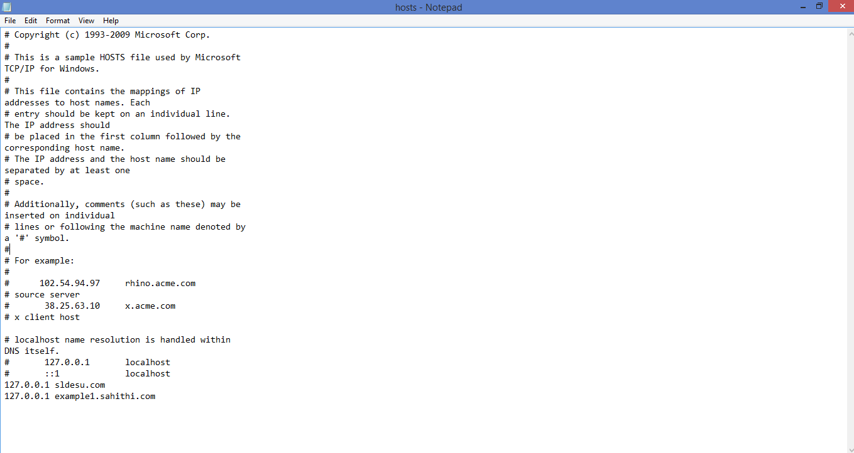

1. Configuring Apache virtual hosts

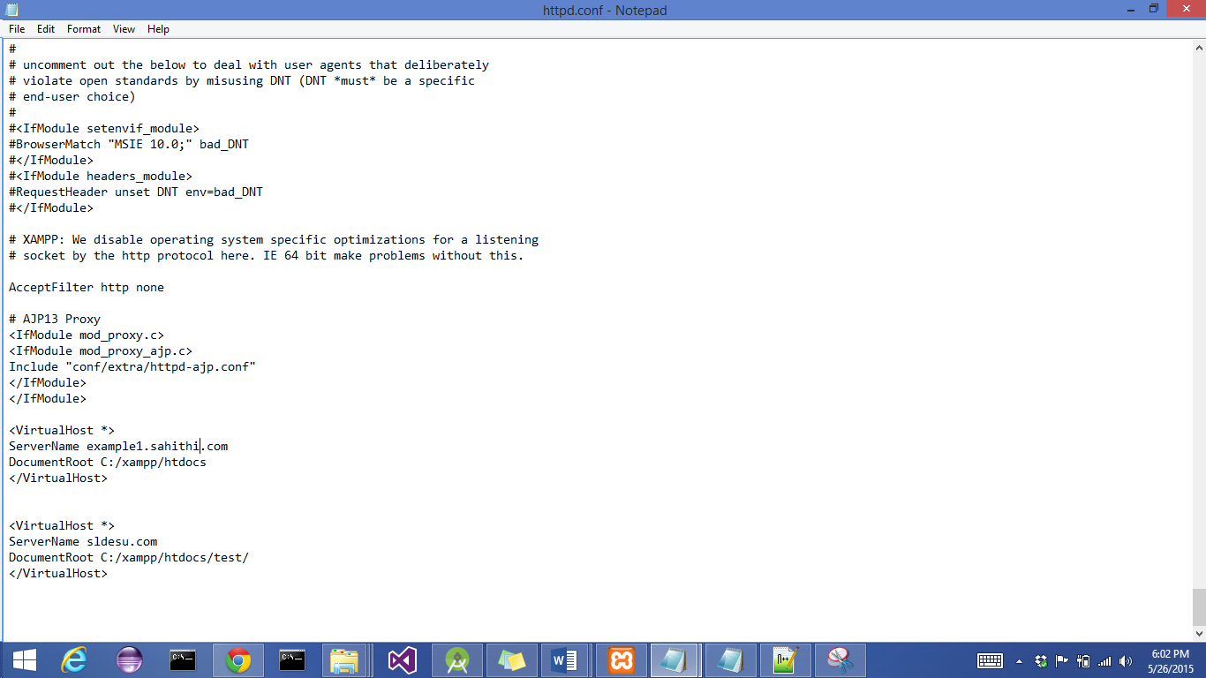

1. Php code 1:

Location: xampp/test/index.php

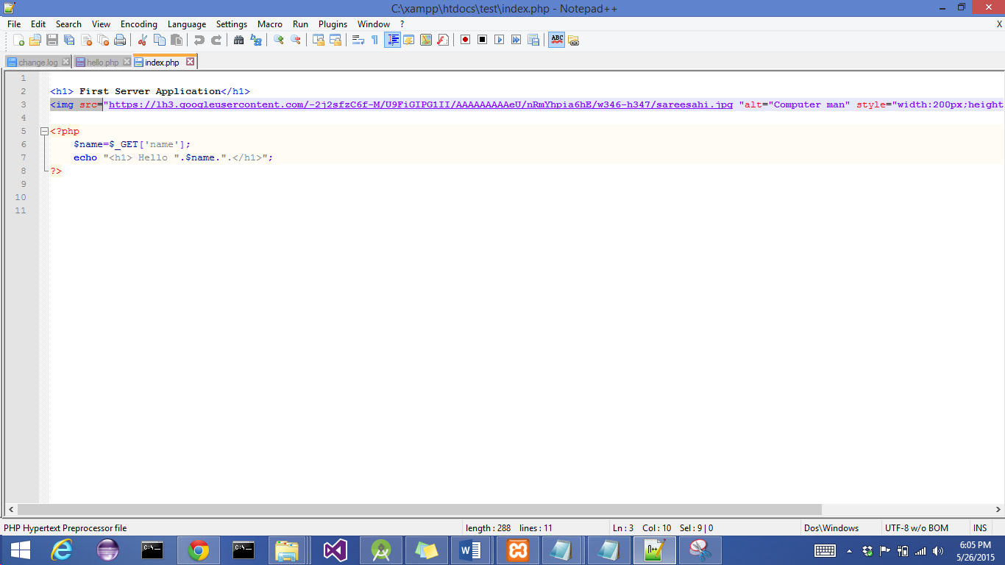

1. Running sldesu.com/?name=Sahithi

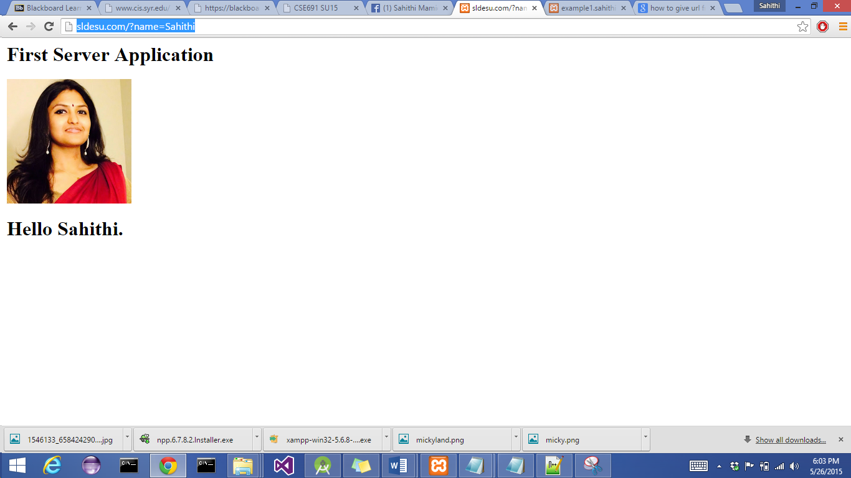

1. Php code 2:

Location: xampp/index.php

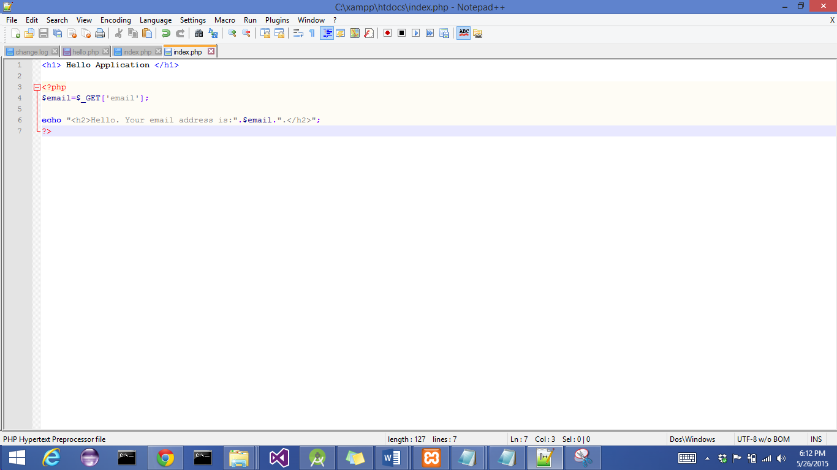

1. Running <http://example1.sahithi.com/?email=sahi.desu25@gmail.com>

